

***King Abdul-Aziz University***

Faculty of Engineering

Mechanical Engineering Department

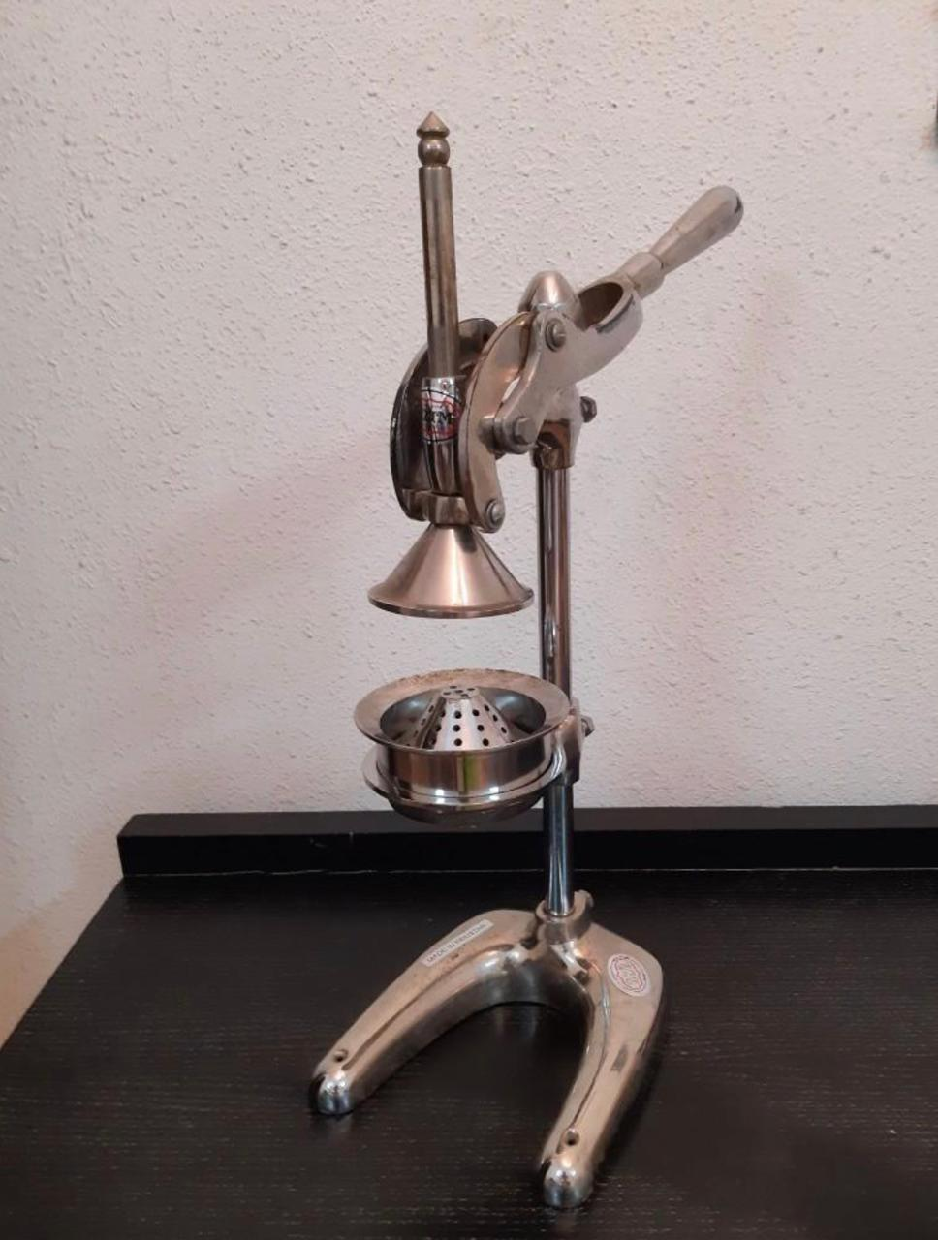

***SolidWork team project***

***(Mechanical juicer)***

***29/11/2020* Instructor:** Dr*. Mamdouh Al-Gendy* ***Fall-2020***

|  |  |  |
| --- | --- | --- |
|  | Names | ID number |
| 1 | Ahmed Jamal Harbi | 1847432 |
| 2 | Jayez AL-Rashidi | 1847488 |

***Contents:***

|  |  |
| --- | --- |
| Pages | Topics |
| 3 | Introduction |
| 3 | Functions |
| 3 | Importance |
| 3 | Method of use |
| 4 | Comparison |
| 5 | Solidwork models |
| 6 | Numbering system |
| 7 | Sup-Assembly |
| 10 | Drawing sheets |

***Introduction:***

As engineers, we must know how to design all parts in all areas. In this project it was required that we choose a manual device after that, we must disassemble and measure all its parts. My colleague and I, after researching, chose a hand juicer designed to make fruit juice such as orange, pomegranate, and lemon. In this project, we used solid works and applied most of the characteristics we learned in MENG204 engineering drawing material such as exploded view, dimensions, tolerance, surface Finish. Our project is a manual tool made of mechanical parts designed to convert fruits into juice.

***Functions:***

Its main function is to convert fruits into juice, such as orange, apple, lemon, and others.

***Importance:***

Mechanical juicer is found in most homes and juice shops, due to its high quality, ease of use, low price, and most importantly for the user is available at any time and any place.

***Method of use:***

To use it we cut the fruit in two halves and putting one half on the strainer then, as we see pulling the handle to move the head to be on the fruit and push it down and get its juice out of it without the seeds and fresh.

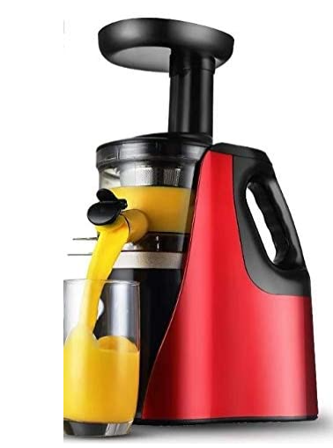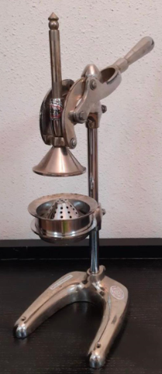***Comparison:***

|  |  |  |
| --- | --- | --- |
|  | *Mechanical juicer* | *Electric juicer* |
| *Price* | ***100SR*** | ***200SR*** |
| *Weight* | ***6.67Kg*** | ***6.14Kg*** |
| *Economic* | ***More*** | ***Less*** |
| *Material* | ***Steel*** | ***Steel*** |
| *Application* | ***Easier*** | ***Difficult*** |

***Solidwork models:***

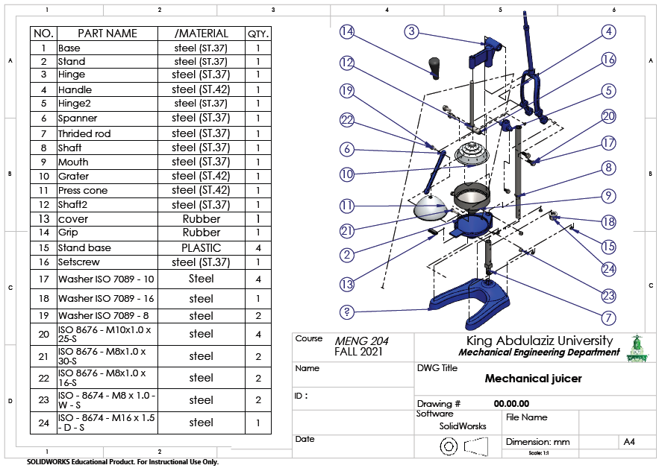

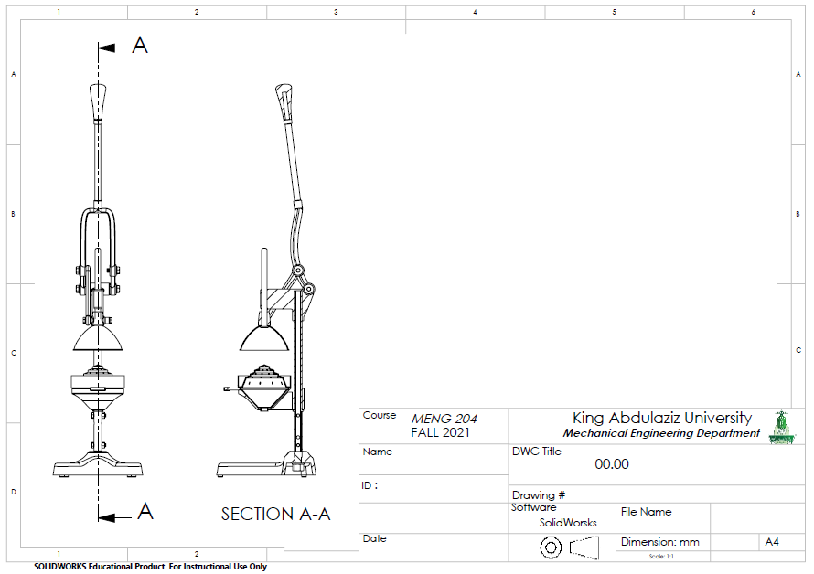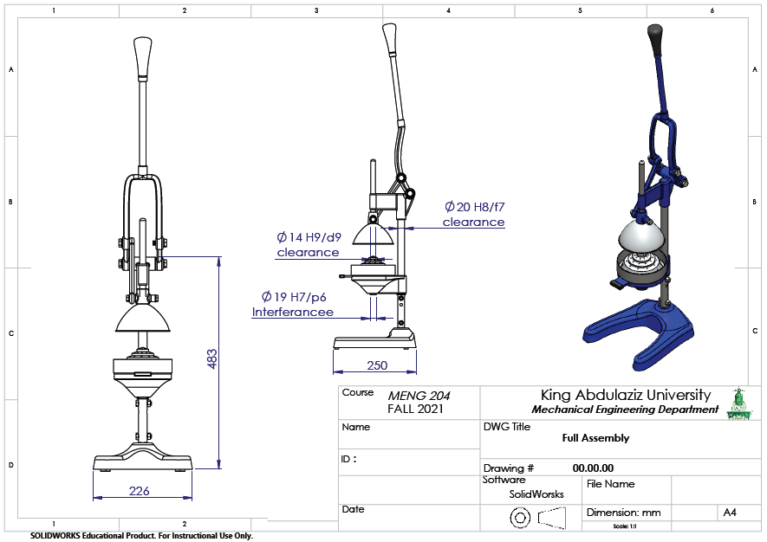

***Numbering system:***

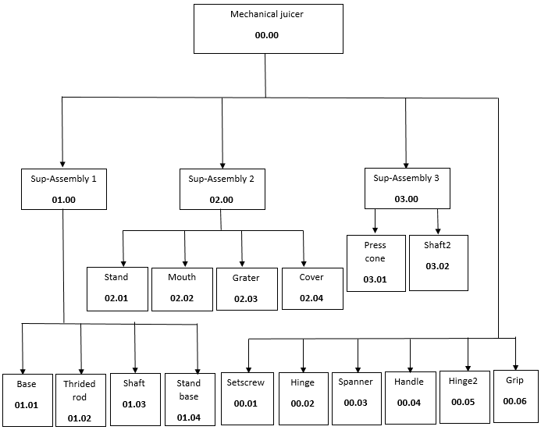

***Sup-Assembly:***

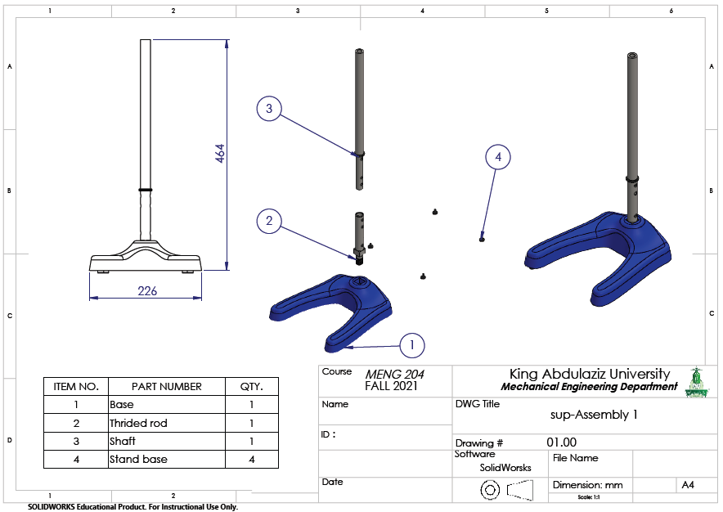

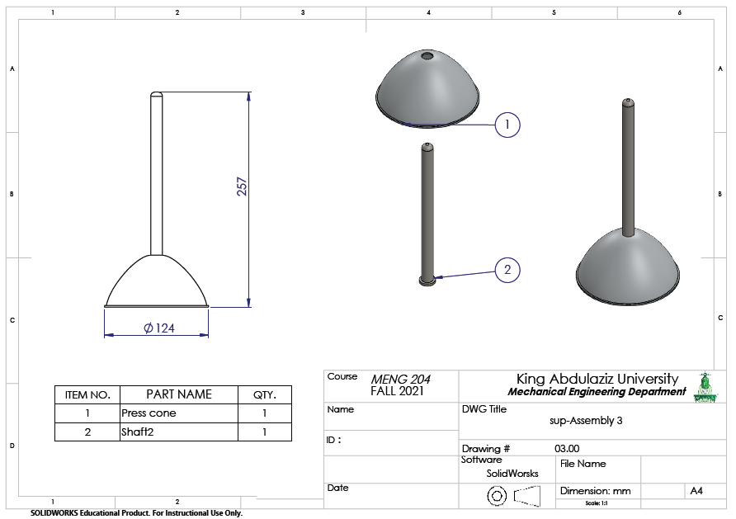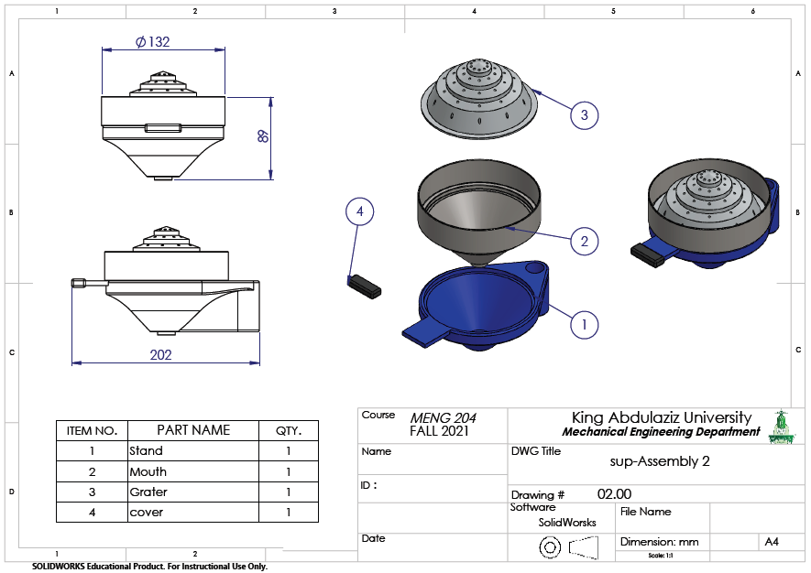

***Drawing sheets:***



